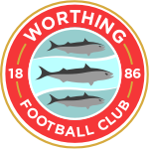
Worthing Football Club: “We Are Worthing”
Review of Our Community Focus for the 2019-2020 Season

- Introduction

  - When George Dowell became the owner of Worthing Football Club (WFC) in 2015, he developed a 5 year plan to transform the Club. An obvious and important strand of this plan was to achieve promotion of the Men’s first team from the Isthmian League to National League South. This would be considered in most Clubs to be the sole raison d'être for such an organisation: the success of the Men’s team is a key determinant in whether the Club will generate sufficient funds (through gate receipts and sponsorship) to survive. However, George felt that an equally important strand of work for WFC was to use “football” (both playing and supporting) as a way to create a community hub with shared interests and goals.

  - The 2019-2020 season saw significant steps forward for the plan to achieve promotion for the Men’s team, even though the results were declared null and void due to the pandemic. However, this season also saw positive developments for WFC as a Community Hub with a football focus for Worthing. These achievements are described in the report.

  - In the current climate, the ambitious plan to develop and improve the Club as a community hub will need to be modified, as it is anticipated that the Club will be facing severe financial challenges during a period in which there will be intense competition for fundraising. There are also the challenges of continuing requirements of social distancing, which will restrict the opportunity for our football family to physically meet together. The report therefore proposes a strategy that will help the Club to work within the changed landscape that we will face as the outcomes from the pandemic are experienced within our community.

- Background

  - Whilst the premier league clubs may deal in million pound wage bills and expensive entrance fees that may prevent many people from accessing the games, lower league football are often run on a shoestring, relying heavily on local sponsorship, supporters and volunteers to keep going.

  - WFC moved to the Woodside Ground in 1901, during the glory days of football as a ‘working class’ game, and record crowds of over 3000 supporters. Since then our fortunes have fluctuated and the club almost folded in 2015 with a combination of poor results and lack of funds. The Club was rescued by George, who had a vision to create a community football club for Worthing. Following his accident, he had set up a new team formed of a group of friends and colleagues who were willing to play for him, starting at the lowest level. He then realised that there was an opportunity to both save Worthing’s historic club and realise his “5 Year Plan.”

  - Over the last five years, a number of “not for profit” activities have been developed by the Club that offer beneficial outcomes for the Worthing Community. The Club prides itself in welcoming all ages and abilities to the club, both as supporters and players. We are particularly family orientated and feel we have a special understanding of how important it is to make our activities accessible for those who may have limited mobility.

  - We understand WFC is a unique community asset that offers significant opportunities to encourage positive attitudes to physical and mental health and wellbeing: it is the only venue within walking distance of the centre of Worthing when hundreds of local people gather together regularly to enjoy a shared and, for some, a lifelong interest. Our next steps are to build on the activities described below and target them towards the areas of greatest need within our local community.

- Community Activities Developed in the 2019-2020 Season.

  - Men's First Team Matches: Events bringing the football family together.

    - The strong foundation of WFC is built on the success of our Men's First Team. This is the team that draws the crowds and generates the greatest income for the Club, from ticket sales, food and drink at home matches to sponsorship from local businesses.

    - The regular matches and training sessions provide a fantastic community event at a venue that can be easily reached by local people: many walk to the ground or use public transport. It offers the opportunity to enjoy a shared experience and to mix socially, whether or not one has a partner or friend to go with. This is particularly important for the a significant section of our supporter base, that of older men. Research indicates that this group tends to have less networks of friends than women of a similar age and rarely share personal concerns about health and personal worries. For some, this can lead to social isolation and depression (see Appendix A). Not only do match days offer the opportunity to increase social networks, but we also have the Worthing Seniors football team for the over 50’s, and promote the local Walking Football team for older men who like to continue playing football

  - The 12th Man: Worthing's Supporters.

    - Worthing's supporters are well known for their vocal and enthusiastic support of their Club. A group of volunteers have set up a Supporters Association (WFCSA), which aims to fundraise for the Club and give a voice to the fans.

    - The Committee for the Association has representatives from all areas of the Club, with members aged 16 to 70. The WFCSA feel it is important to understand the different segments of the supporters groups, because although we have a keen young fan base who readily turn to social media to keep in touch, we also have a significant group of older fans who do not use the internet and rely on face to face and hard copies to keep updated.

    - In addition to active fundraising, the Association aims to build good connections at all levels across our football family. This has included the launch of a Fanzine available at matches or by post, live broadcasts at home and away games, plus Podcasts. The WFCSA also paid for certain matches to be filmed and broadcast on YouTube via “Your Instant Reply” when Club funds were not available to pay for them. These form an important link for supporters who may not be able to attend games, such as due to ill health or other commitments. For younger supporters, birthday cards are sent signed by the Manager and sweets provided at Christmas and Easter.

    - The Association also offers friendly one to one advice on how to make best use of IPads and phones for people who are less confident in using IT and social media.

    - WFCSA have regularly raised over £2000 a year from membership subscriptions and fundraising and has worked in partnership to complete works at the Grounds that benefit all supporters: bearing in mind the needs of our supporters and visitors to Woodside, improvements to the ground currently being funded by the volunteers of the WFCSA are the refurbishment of the accessible toilet and provision of a baby changing area.

  - The Women’s Team

    - Whilst football might have been traditionally viewed as a ‘boys’ game’, it’s worth remembering that women played in a league of their own up until 1921, when the FA banned women from playing. This understandably put a considerable check on the development of the women’s game, but the recent excellent performances by the Lionesses on the international stage has helped to stimulate local interest.

    - Two years ago, WFC successfully launched a Women's team which is achieving some sponsorship income but still relies on the club for around two thirds of its funding. WFC feel that supporting a Women's team is essential to keep providing positive role models for girls who's interest in sport decreases as they become teenagers.

    - We recognise that research has highlighted the need for inspirational role models and, also, local 'influencers' such as sibling, parents and teachers (see Appendix B.) By encouraging the wider community to engage, girls will feel supported in making more informed choices.

    - On a practical level, this season our Women's Team Manager ran a pilot project to look at increasing awareness of the team’s activities and to encourage more families to attend. Free tickets were provided for schools and active engagement used to promote the Women’s game and encourage young people to come to the matches with their families. The pilot was very successful, with over 170 people attending and plans had been made to develop this approach with schools and offer special training sessions to encourage not only young women to get physically active, but all women to gain an insight into the benefits of being part of the football family.

  - A Welcoming, Inclusive and Family Club

    - A competitive team sport such as football can improve physical fitness, develop social skills, increase personal resilience and increase mental wellbeing. Youngsters learn the give and take of working together as a team and how to cope with failures, as well as enjoying their positive achievements.

    - WFC is a community orientated club and believe that it’s never too early to become part of the football family. On match days, the focus is on welcoming all ages to enjoy the event, not least children being encouraged to come onto the pitch at the end of the match for a kick around. A recent initiative is the “Fans matches” where supporters have formed a team to play against other clubs fans: in one our manager Adam Hinshelwood stepped into the breach and helped our WFC team to win the match.

    - For girls and boys who enjoy playing, WFC have created a Development Centre from U8’s through to U16’s aimed at giving all local young players a chance. This particularly addresses a local need identified by the West Sussex County Council Joint Strategic Needs Assessment for 10-11 Year Olds (See Appendix C.) We offer an opportunity to engage in a positive physical and social actively that is 'close to home' - particular important for families on low income and limited access to transport.

    - We have extended our Youth Programme to include U14/U15/U16 teams alongside our U18s, and successfully launched an Academy programme in which boys study for a BTEC Sport Diploma and compete in a National Alliance U19.

    - In addition, this year, WFC launched "Worthing Inclusive", a new disability team. As stated in the Club's press release: "The side consists of 20 plus lads with all different types of disabilities with amazing team bond who are always looking for a new challenge. The Sussex disability league is the only one of its kind in the county. Worthing will be taking on four teams making them the second highest contributor in the league joint with 1066 specials and only trailing to Brighton and Hove Albion in the community. The Pan Disability league means that players with all types of disabilities can take part." (See Appendix D.)

    - But it's not just 'the beautiful game': The Woodside Bar provides the opportunity to work with and support local businesses and charities with specific events, such as "The Grand Football Match" in aid of Care for Veterans (see Appendix E) and regular events, such as Dementia Friendly Worthing's 'Sporting Memories' sessions, where older sports fans from Worthing have the chance to share their sporting memories with like-minded people at a weekly club (See Appendix F.)

    - Our aim is to welcome all ages and abilities into our football family.

- The Future's Bright

  - We recognise that WFC and the whole of our community are facing enormous challenges in the year ahead. At the time of writing, the UK is still under strict Lockdown. Social distancing is being rigorously enforced and no physical public meetings are permitted. The Football League system is in freefall and there is lack of clarity as to when the season might start.

  - This means that our traditional methods of sustaining our Club are on hold: there are no matches, so no ticket sales, no opportunity for fundraising at the home games and so on. The focus, at present must be on preserving our Men's First Team and a place for them to play. Seeking out grant funding and reducing outgoings are high on the list of priorities.

  - We also recognise the risk that our 'not for profit activities could be jeopardised and we need to adapt and change in order to survive. We believe that we can play a significant role in reducing health inequalities and improve mental and physical health within our local community. National and local research puts considerable emphasis on 'Place Based' approaches (see Appendix G.) As a Club embedded in the Worthing Community for over 100 years we believe we are well placed to take this forward. We will, therefore, be looking at creative ways to enable our Club to prosper and to work with local organisations, authorities, businesses, charities, our supporters and the Worthing Community as a whole to target our efforts and achieve this. This requires a well informed and planned approach.

- The WFC Community Strategy

  - We will use national and local research and feedback to identify needs in our local community.
  - We will explore ways in which the activities and membership of our Club may be able to have a positive impact on the physical and mental health and wellbeing of our community.
  - We will determine a set of activities that we believe are feasible, desirable and sustainable for the WFC.
  - We will review the success of the activities we have carried out and use feedback to improve our approaches.

- Conclusions

  - Worthing Football Club is a key community hub within Worthing. Whilst our Men's First Team provide the 'engine' to run the Club, we also aim to provide a range of activities that provide targeted support to improve the health and wellbeing of our local community. These types of activities are mainly 'not for profit' and some (such as the Women's Team') are run at t a loss.

  - Whilst we are limited in the plans that we can make at the moment and recognise that we will have to make changes, we are determined to maintain our commitment to provide a family club that welcomes every age and ability.

  - We will carry out our strategy and actively seek new sources of funding and work with local organisations, authorities, businesses, charities, our supporters and the Worthing Community as a whole. We also recognise, however, that we will need to target our resources carefully and will use local research and our knowledge of our community to guide our decisions.
Approved by George Dowell, WFC Owner, 12.5.20
Appendix A
Quote from a Research Article from the MIND Website.
https://www.mind.org.uk/news-campaigns/news/men-twice-as-likely-as-women-to-have-no-one-to-rely-on-for-emotional-support/

"Men twice as likely as women to have no one to rely on for emotional support
Thursday, 30 June 2016 Mind

Research out today from the mental health charity Mind¹ has found that men are twice as likely as women to have no one they could rely on for emotional support (9% vs. 5%).
- One in ten men and one in twenty women currently has no one they can rely on for emotional support
- Half of men admit they feel uncomfortable talking about emotions compared with two in five women
- Men more reliant on partner for support, while women prefer family and friends

Despite the fact that talking about problems, including mental health problems, is one of the best ways of dealing with them, almost half of people (47%) also admit they feel uncomfortable opening up about emotions to people close to them. This is noticeably higher in men, over half of whom are uncomfortable opening up (52%), compared with two in five women (42%).

While men are most likely to rely on their partner when they need emotional support, women are more likely to turn to family or friends instead. This is reflected in the relative size in women’s support network, as they are also more likely than men to have five or more people they could rely on for emotional support (39% vs. 29%)...."

A number of projects have been set up including, for example, "...The 12th Man Project: Based in Suffolk the 12th Man project aims to help men find it easier to talk to each other about their mental health. In football, the fans are the 12th man, the extra support that makes all the difference. The 12th man represents help when it's needed the most. The group are receiving training and support to run events across Suffolk to support other men to open up and support each other's mental health...."

Appendix B. Worthing Football Club: Promoting the Women's Game.

Women In Sport FA Case Study.
https://www.womeninsport.org/wp-content/uploads/2017/10/The-FA-Case-Study.pdf
" The FA runs an established ambassador programme, enabling female football players to share their stories and inspire at a local level.
Female players have been visiting schools and community groups for a number of years now, but The FA needed to assess the impact of player appearances on growing female participation and raising the profile of the game.
Women in Sport embarked on a research project to explore the programme, while hoping to unlock influencer opportunities linking to our ‘What Sways Women to Play Sport?’ research released in 2015."

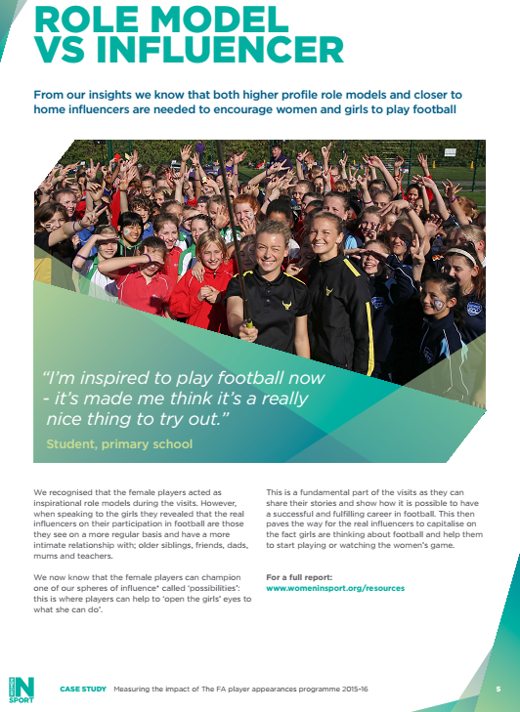
Women In Sport Research.

https://www.womeninsport.org/research-and-advice/our-publications/reframing-sport-for-teenage-girls-building-strong-foundations-for-their-futures/

Reframing Sport for Teenage Girls: Building Strong Foundations for their Futures
Published 2019

KEY FINDINGS
We uncovered five important anchors which reflect what girls’ value most in their lives and these build the foundations of who they will become;
- Support Network – family and friends give girls a sense of place in the world, relationships with mums being particularly important.
- Socially Connected – social media use gives girls validation, time dedicated to this means de-prioritising other activities.
- Independence and New Experiences – girls want independence and freedom to make choices and have new exciting experiences, which build formative memories.
- Moment of Pride – a sense of achievement that fuels self-worth, builds confidence and personal growth.
- Keeping on Top of it All (re-prioritisation) – girls have to set their own priorities, what they ‘must do’ vs what they ‘want to do’ in their day-to-day lives.
We need to reframe sport and physical activity as something that girls’ value and perceive to enhance their lives. We have developed 8 Principles of Success to support organisations to bridge the ‘relevance gap’ in sport for girls and ensure it has a more meaningful place in their lives.

The 8 Principles of Success
- No Judgement – take the pressure off performance and give girls freedom simply to play
- Invoke Excitement – bring a sense of adventure and discovery.
- Clear Emotional Reward – reframe achievement as ‘moments of pride’, not winning.
- Open Their Eyes to What’s There – redefine sport as more than school sport.
- Build into Existing Habits – tap into existing behaviours in other spheres.
- Give Girls a Voice and Choice – allow girls choice and control to feel empowered.
- Champion What’s in it for Them – make it much more than just about health.
- Expand Image of What ‘Sporty’ Looks Like – create truly relatable role models which inspire.

RECOMMENDATIONS
- Expand the relevance of sport to meet all girls needs
- Make the sports opportunities truly hard to resist – FOMO!
- Apply the 8 Principles of Success in developing and evaluating initiatives
- Collaborate more as a sector to build long-term solutions with wider and sustainable impact

Appendix C
Worthing Football: Targeting the areas of our Community with Greatest Need.
WSCC JSNA Infographics: https://jsna.westsussex.gov.uk/updates/infographic-posters/

Appendix D : The Launch of "Worthing Inclusive"

Worthing Inclusive Introduced https://worthingfc.com/2019/08/worthing-inclusive-introduced/
22 August 2019, 12:45 BST

Worthing Football club are delighted to announce that they are starting a new disability team as of this season. This comes after the team last year folded but with strong interest and players such as Michael, Martin and James wanting to keep a group together a new team will be formed for the upcoming season.
With new coaches Jordan, Paul, Andy and Callum all joining the team they are hopeful of following previous years of success. This success including the Championship team winning the Chelsea F.C disability tournament which meant they got the privilege to play on the hallowed turf and come the end of the tournament lift the trophy. Not to forget the Prem Pink team winning the local Lancing Disability league and The Prem yellow team winning the League round cup. The boys are keen to continue this success.
The side consists of 20 plus lads with all different types of disabilities with amazing team bond who are always looking for a new challenge. They started training for the upcoming season on the 26th of July.
The Sussex disability league is the only one of its kind in the county. Worthing will be taking on four teams making them the second highest contributor in the league joint with 1066 specials and only trailing to Albion in the community. The Pan Disability league means that player with all types disabilities can take part.
We spoke to Jade Harker who is the football development officer specifically for disabled football at Sussex FA. Jade was delighted at Worthing getting involved, “it’s great to see local mainstream clubs getting involved with and supporting disability football right here in Sussex”.
Jade also expressed her delight at Worthing entering four teams, “Worthing will be supporting four teams who will compete in the Sussex Disability league and I believe this is a section of the club that will flourish”.
Worthing FC Inclusive team are always looking for new members and the sessions are open to anyone over the age of 18 with any form of disability.
If you would like to join or want some more information on joining please do not hesitate to contact worthingfcinclusive@gmail.com.

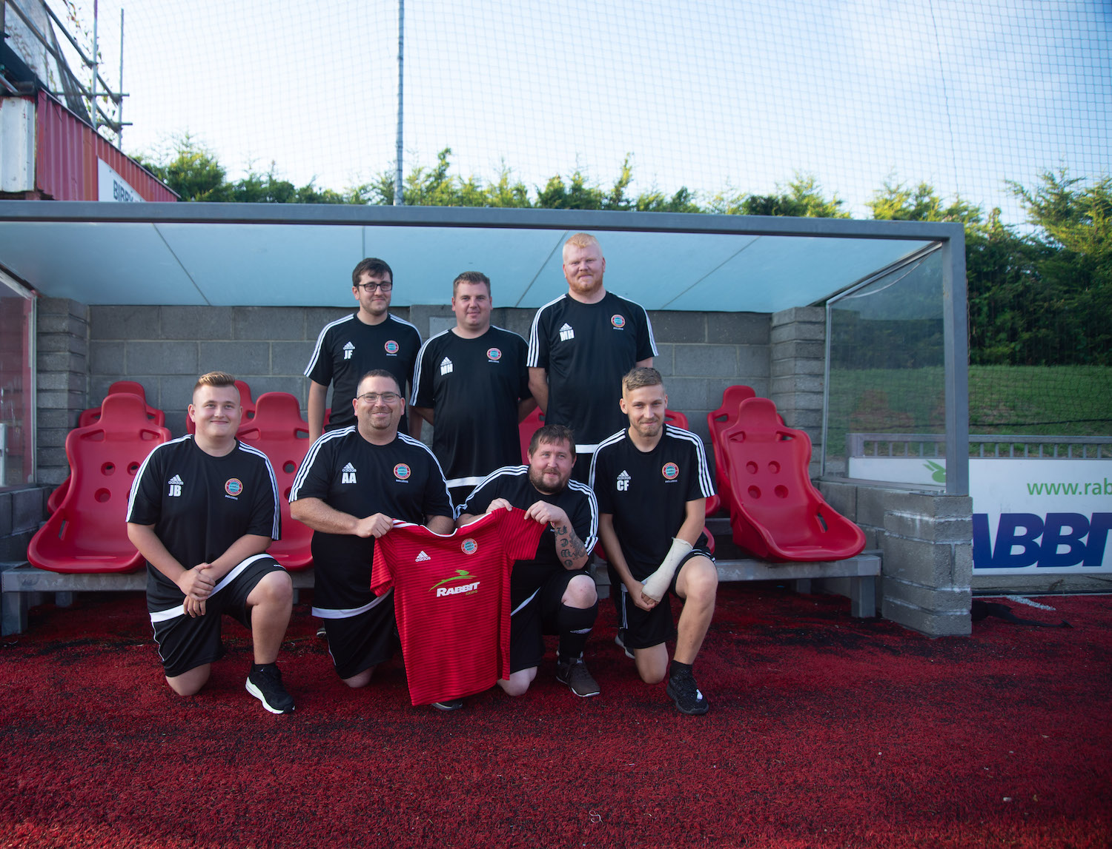

Appendix E. Worthing Football Club: A Historic Club representing the Worthing Community
"A Grand Football Match" : Advertisement for the Event and Photographs taken at the Event.
https://worthingfc.com/2018/09/a-grand-football-match/
28 September 2018, 15:16 BST
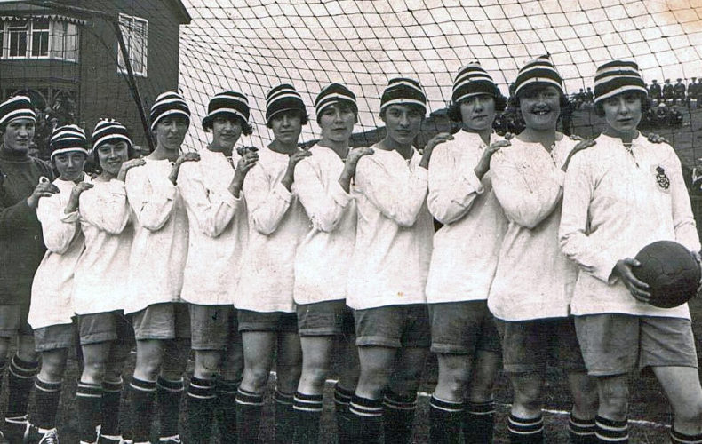
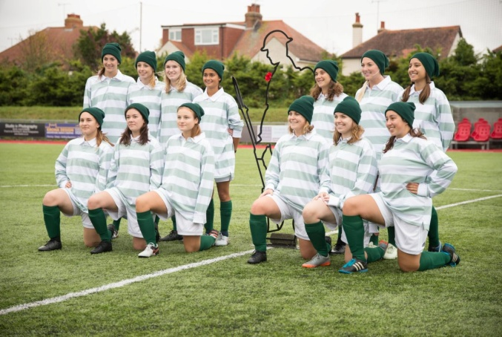

Advertisement for the Event:
On Sunday 14 October, Worthing Football Club is hosting a special football match in aid of Care for Veterans.
This one-off game is a recreation of a match that was held at the club 100 years ago between Worthing Ladies’ XI and Wounded Soldiers from the Grange Auxiliary Hospital.
The Grand Football Match, as it was also originally called, aims to be as authentic as possible, with WWI themed sounds, dress, atmosphere and refreshments. There will be live music from Lancing Brass Band and 1066 Pipes & Drums marching band, chances to win prizes, and more!
All spectators are encouraged to dress-up in period dress from the WWI era, with prizes for the best dressed!
Match: Serving soldiers from The Princess of Wales’s Royal Regiment vs University of Sussex Ladies’ Team

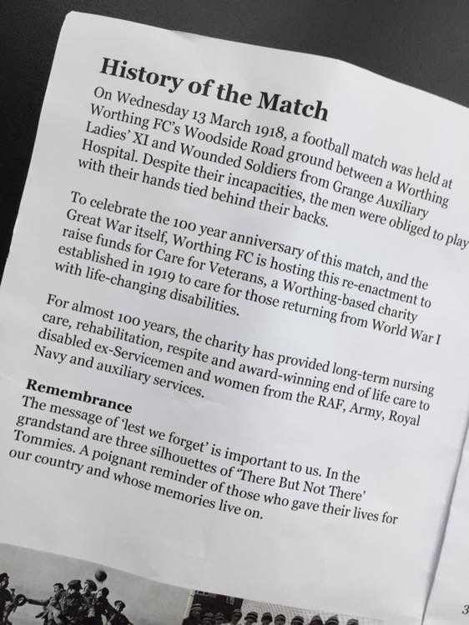
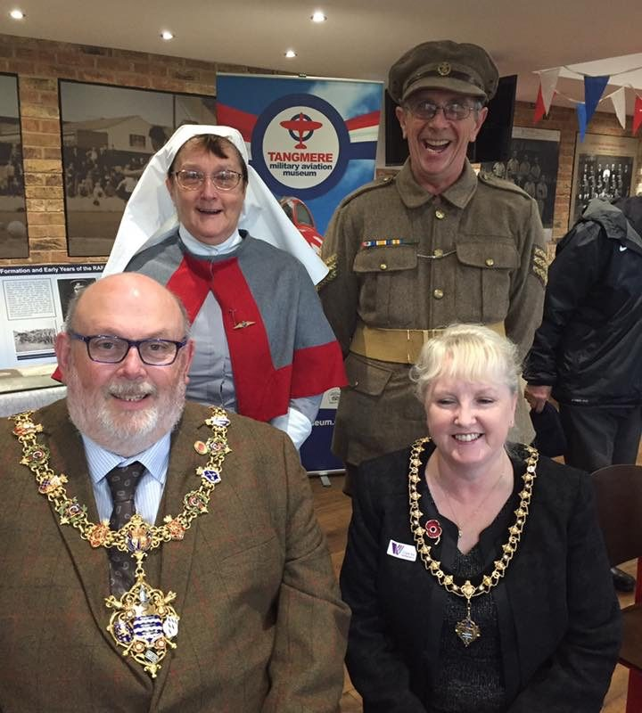

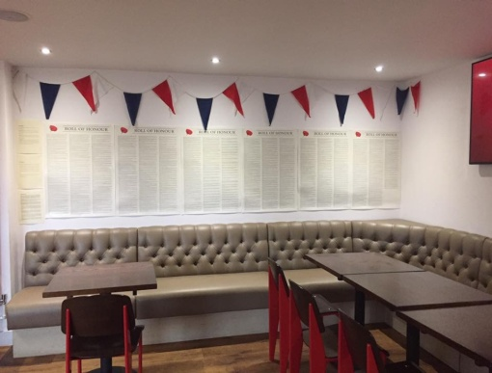
Appendix F. Worthing Football Club: Working With Partners to Support the Worthing Community.
Sporting Memories: https://worthingfc.com/2019/03/share-your-sporting-memories/

SHARE YOUR SPORTING MEMORIES
20 March 2019, 17:00 GMT
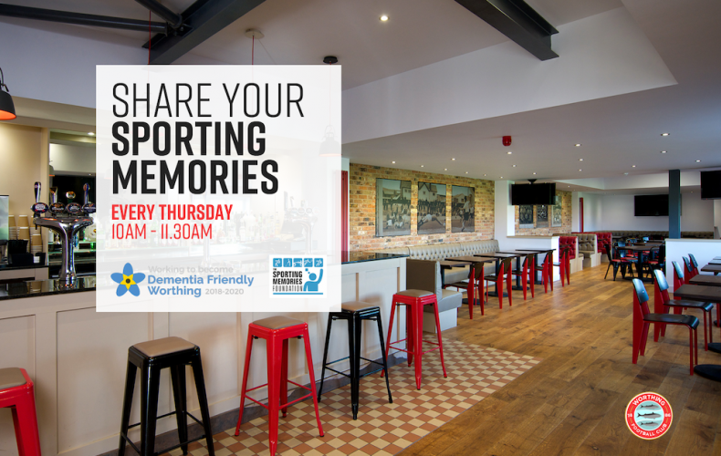

Older sports fans from Worthing will have the chance to share their sporting memories with like-minded people at a new weekly club that starts soon at Worthing Football Club.

The sessions will take place between 10 am and 11.30 am in the clubhouse at Worthing Football Club every Thursday from 21 March with the aim of engaging older members of the local community in social activities through their love of sport.
This follows on from that success of the group that has been running at the Sussex County Cricket ground in Hove. Organised by the Sussex Cricket Foundation, the charitable arm of Sussex Cricket, with help from local volunteers and the Worthing Dementia Action Alliance, it is only made possible through the generous support of Worthing Football Club.
Volunteer training, mentoring and resources are being provided by The Sporting Memories Foundation, the national charity that tackles dementia, depression and loneliness through its unique blend of social activities, sporting reminiscence and games.
Sessions will utilise a wealth of archive photographic, video and audio material – provided by The Sporting Memories Foundation – to stimulate discussion and reminiscences amongst participants.
Participants that would like to, will also have the opportunity to take part in low-intensity games and activities for all abilities.
Linda Bowen, Sussex Cricket Foundation said “Keeping active and socialising is key to good physical and mental wellbeing. The aim of this club is to provide a fun, sociable and friendly atmosphere where sports fans or ex-players are able to simply talk sport!”
“Whilst this group is meeting at the Football Club all sports will be covered, not just football. There is just as likely to be a discussion about boxing, motor racing or rugby. The group is designed to be accessible to all, regardless of age, ability or fitness level and I would encourage people to get in touch to find out more, or to simply drop in on Thursday at the club in Woodside Road, Worthing. The sessions are a great way to meet new people, chat, and have a brew in a friendly and welcoming environment. They are free and the laughter is plentiful – everyone is welcome.”

Appendix G: National and Local Research regarding Place-based approaches for reducing health inequalities.

The Public Health England Place-based approaches for reducing health inequalities: foreword and executive summary
https://www.gov.uk/government/publications/health-inequalities-place-based-approaches-to-reduce-inequalities/place-based-approaches-for-reducing-health-inequalities-foreword-and-executive-summary

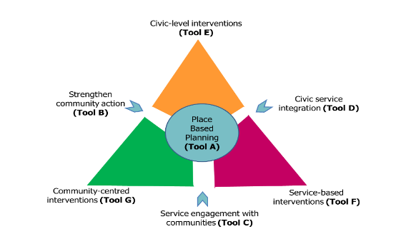
https://www.peopleshealthtrust.org.uk/news/news-stories/place-based-approach

Adur and Worthing Council Strategy: Platforms for our Places. Going Further: 2020-2022
https://www.adur-worthing.gov.uk/media/Media,156442,smxx.pdf

“2.4.6 Live Well - Active People and Places- Leisure & Activity Strategy:
a) Develop and Implement an Open Spaces, Sport and Recreation Strategy building on the outcomes of the consultancy report due by end 2010 and result from our facilities condition survey
b) Launch and implement our community led Activities Strategy
c) Create a community based strategic group to lead this work "

